A PROJECT REPORT ON
AUTOMATED ANDROID MALWARE DETECTION USING OPTIMAL ENSEMBLE LEARNING APPROACH
Submitted in partial fulfilment of the Requirements for the award of the Degree of
MASTER OF COMPUTER APPLICATIONS
BY
CH. Hema Sri
REGD.NO:Y24MC13012
UNDER THE GUIDANCE OF
P. Premeela

THE DEPARTMENT OF MCA

DEPARTMENT OF MASTER OF COMPUTER APPLICATIONS
HINDU COLLEGE PG COURSES
GUNTUR – 522007


ACHARYA NAGARJUNA UNIVERSITY
GUNTUR
APRIL - 2025
CERTIFICATE
*****ISSUED BY COLLEGE STAFF*****


PROJECT AUTHORIZATION LETTER

DECLARATION BY CANDIDATE

I CH.Hema Sri here by declare that the Project Report entitled ““AUTOMATED ANDROID MALWARE DETETCTION USING OPTIMAL ENSEMBLE LEARNING APPROACH” done by me under the guidance of P.Premeela, Associate Professor, being submitted to the Department of MCA. Approved by AICTE and affiliated to Acharya Nagarjuna University, Guntur for the award of degree of MASTER OF COMPUTER APPLICATIONS. This is a record of Bonafede work done by me and it has not been submitted to any other Institute or University for the award of any other degree.

(CHANDIKA. HEMA SRI)
Y24MC13012

ACKNOWLEDGEMENT
I feel myself honored to place my warm salutation to HINDU COLLEGE PG COURSES, GUNTUR. Department of MCA, which gave me the opportunity to have a strong base in MCA and profound knowledge.

I wish to express my profound deep sense of gratitude to Dr. S.V. RAMANA, Principal of HINDU COLLEGE PG COURSES for his effective encouragement and enthusiastic guidance for the successful completion of my project work and for providing me all the necessary amenities that helped me to complete my project work within the stipulated time.

I am indebted to DR.CH.SUBBARAO, Head of the Department for her continuous support and valuable suggestions for successful completion of my project work.

I express my thanks to the organization “CEGON TECHNOLOGIES” for having confidence in me and making use of my activities by offering this project. I also express my special thanks to Mr. NARAYANA PASUPULETI, Director for guiding me in right way and helped me in this project.

Finally, I take this opportunity to extend my full-heartened thanks, gratitude and respect to the Department Lecturers, all my friends, parents and well-wishers for giving me valuable advice and constant support in all possible ways.
ABSTRACT

As of late, the uses of advanced mobile phones are expanding relentlessly and furthermore development of Android application clients are expanding. Because of development of Android application client, some gate crashers are making vindictive android application as instrument to take the delicate information and data for fraud and misrepresentation portable bank, versatile wallets. There are such a large number of malevolent applications discovery instruments and programming’s are accessible. Be that as it may, a viably and productively vindictive application recognition device expected to handle and deal with new complex pernicious applications made by interloper or programmers. This paper Utilizing Machine Learning approaches for distinguishing the malignant android application. First, dataset of past pernicious applications has to be obtained with the assistance of Help vector machine calculation and choice tree calculation make up correlation with preparing dataset. The prepared dataset can foresee the malware android applications up to 93.2 % obscure/new malware portable application..
The main steps performed through this framework are sketched as follows:
1. A set of features is computed for every binary file in the training or test datasets, based on many possible ways of analysing a malware.
TABLE OF CONTENTS

S.NO | CONTENT | PGNO
1 | Introduction  - Objective  - Problem Statement  - Software requirements  - Hardware requirements | 1-7
2 | Feasibility study | 8-10
3 | Literature survey | 11-21
4 | System analysis  4.1 Existing system  4.1.1 Disadvantages of existing system  4.2 Proposed system  4.2.1 Advantages of proposed system  4.3 Functional requirements  4.4 Non-Functional requirements | 22-26
5 | System design  5.1 System architecture  5.2 UML diagrams | 27-36
6 | Implementation  6.1 Modules  6.2 Sample code | 37-54
7 | Software environment | 55-72
8 | System testing  8.1 Testing strategies  8.2 Test cases | 73-76
9 | Screens | 77-93
10 | Conclusion | 94-95
11 | References | 96

LIST OF FIGURES
S.NO | NAME OF THE DIGRAM | PAGE.NO
1 | System architecture
2 | System architecture
3 | use case diagram
4 | Class diagram
5 | Activity diagra
6 | Sequence diagram
7 | Collaboration diagram
8 | Component diagram
9 | Deployment diagram
10 | Packages
11 | completion of installation
12 | Finish setup
13 | Static testing
14 | ACCURACY COMPARISON GRAPHS OF CBET DATASET
15 | PRECISION COMPARISON GRAPHS OF CBET DATASET

LIST OF TABLES
- Test cases table

- INTRODUCTION
The rapid growth of mobile devices and remarkable advances in 4G/5G mobile networking technologies have both inspired and facilitated a plethora of mobile applications (apps). In support of these mobile devices, various mobile operating systems have been developed, such as Android, iOS, and BlackBerry 10, etc. Among these mobile operating systems, Android has become the most popular one because of numerous mobile apps it provides. Unfortunately, smartphones running Android have been increasingly targeted by attackers and infected with malicious apps: according to the mobile threat report released by F-Secure in 2014 Q1 [1], over 95% of malicious apps were distributed on the Android platform. Moreover, as the major sources of Android apps, third-party markets contain a lot of cracked or tampered apps, and there is no sign to indicate whether the apps have been checked for security risks or not in these third-party markets. The lack of security inspection on Android apps intensifies the spreading of malicious apps (malware) on the Android platform. Zhou et al. [2] performed some Android malware analysis by popular security software tools, and the detection rate was only between 20.2% and 79.6%, which clearly indicates an urgent and rapidly growing demand on malware detection for Android applications. To address the increasingly wide-spread security risks, the Android platform itself provides several security solutions that harden the installation of malware, such as the Android permission system and Google “Bouncer”. To perform certain tasks on Android devices, such as sending a SMS message, each Android app has to explicitly request the corresponding permission.
1.1 Objective and Future scope:
The primary objective of this project is to develop a robust system for detecting Android malware using advanced machine learning and deep learning techniques.
It aims to identify both known and zero-day malicious applications with high accuracy.
By leveraging ensemble learning, the system integrates multiple algorithms to improve detection performance.
A diverse feature set extracted from APK files will be used to train the models effectively.
The goal is to minimize false positives and false negatives in malware detection.
The system will be tested on standard benchmark datasets and evaluated using accuracy, precision, recall, and F1-score.
It intends to outperform conventional static and dynamic analysis methods.
The model is optimized through hyperparameter tuning and cross-validation.
An emphasis will be laid on scalability for real-time application deployment.
Finally, the project targets a detection accuracy of over 90%, ensuring a secure Android ecosystem.
Future scope:
- The framework can be extended to integrate real-time malware detection and prevention in Android systems. Cloud-based threat intelligence platforms can be connected to update malware signatures dynamically. Future iterations may explore federated learning to enhance privacy while improving model performance. Behavioral analysis through dynamic execution can be added to strengthen detection rates. The model can be integrated with Google Play Store as a screening mechanism for uploaded apps. Edge computing techniques can be explored for on-device malware detection without internet dependency. Continuous learning techniques can help the system adapt to new malware strains without retraining from scratch. The ensemble approach can be improved by integrating deep graph neural networks and anomaly detection models. An alert and response system can be built to quarantine or delete malicious apps automatically. Finally, the system can be adapted for iOS and IoT malware detection, broadening its application domain.
1.2 Problem Statement:
With the surge in Android application usage, the risk of malware attacks has drastically increased. Traditional antivirus and rule-based malware detection systems often fail to detect sophisticated or obfuscated malware. Cybercriminals exploit application vulnerabilities to gain unauthorized access to sensitive user data. Many available malware detection tools are outdated or ineffective against newly generated variants. The evolving nature of malware makes it necessary to adopt adaptive learning techniques. There is a need for an automated system that learns from past malicious patterns and predicts unseen threats. False detections can lead to either security breaches or blocked legitimate apps, impacting user trust. Complex malware can hide within seemingly legitimate applications, requiring smarter detection logic. Hence, a reliable, automated, and intelligent approach is essential to enhance Android security. This project addresses the challenge of detecting such threats using a hybrid machine learning-based model..
1.3 SOFTWARE REQUIREMENTS
Software requirements deal with defining software resource requirements and prerequisites that need to be installed on a computer to provide optimal functioning of an application. These requirements or prerequisites are generally not included in the software installation package and need to be installed separately before the software is installed.
Platform – In computing, a platform describes some sort of framework, either in hardware or software, which allows software to run. Typical platforms include a computer’s architecture, operating system, or programming languages and their runtime libraries.
Operating system is one of the first requirements mentioned when defining system requirements (software). Software may not be compatible with different versions of same line of operating systems, although some measure of backward compatibility is often maintained. For example, most software designed for Microsoft Windows XP does not run on Microsoft Windows 98, although the converse is not always true. Similarly, software designed using newer features of Linux Kernel v2.6 generally does not run or compile properly (or at all) on Linux distributions using Kernel v2.2 or v2.4.
APIs and drivers – Software making extensive use of special hardware devices, like high-end display adapters, needs special API or newer device drivers. A good example is DirectX, which is a collection of APIs for handling tasks related to multimedia, especially game programming, on Microsoft platforms.
Web browser – Most web applications and software depending heavily on Internet technologies make use of the default browser installed on system. Microsoft Internet Explorer is a frequent choice of software running on Microsoft Windows, which makes use of ActiveX controls, despite their vulnerabilities.

1) Software : Anaconda
2) Primary Language : Python
3) Frontend Framework : Flask
4) Back-end Framework : Jupyter Notebook
5) Database : Mysql
6) Front-End Technologies : HTML, CSS, JavaScript and Bootstrap4

1.4 HARDWARE REQUIREMENTS
The most common set of requirements defined by any operating system or software application is the physical computer resources, also known as hardware, A hardware requirements list is often accompanied by a hardware compatibility list (HCL), especially in case of operating systems. An HCL lists tested, compatible, and sometimes incompatible hardware devices for a particular operating system or application. The following sub-sections discuss the various aspects of hardware requirements.
Architecture – All computer operating systems are designed for a particular computer architecture. Most software applications are limited to particular operating systems running on particular architectures. Although architecture-independent operating systems and applications exist, most need to be recompiled to run on a new architecture. See also a list of common operating systems and their supporting architectures.
Processing power – The power of the central processing unit (CPU) is a fundamental system requirement for any software. Most software running on x86 architecture define processing power as the model and the clock speed of the CPU. Many other features of a CPU that influence its speed and power, like bus speed, cache, and MIPS are often ignored. This definition of power is often erroneous, as AMD Athlon and Intel Pentium CPUs at similar clock speed often have different throughput speeds. Intel Pentium CPUs have enjoyed a considerable degree of popularity, and are often mentioned in this category.
Memory – All software, when run, resides in the random access memory (RAM) of a computer. Memory requirements are defined after considering demands of the application, operating system, supporting software and files, and other running processes. Optimal performance of other unrelated software running on a multi-tasking computer system is also considered when defining this requirement.
Secondary storage – Hard-disk requirements vary, depending on the size of software installation, temporary files created and maintained while installing or running the software, and possible use of swap space (if RAM is insufficient).
Display adapter – Software requiring a better than average computer graphics display, like graphics editors and high-end games, often define high-end display adapters in the system requirements.
Peripherals – Some software applications need to make extensive and/or special use of some peripherals, demanding the higher performance or functionality of such peripherals. Such peripherals include CD-ROM drives, keyboards, pointing devices, network devices, etc.
1)Operating System : Windows Only
2)Processor : i5 and above
3)Ram : 8gb and above
4)Hard Disk : 25 GB in local drive
- FEASIBILITY STUDY

Feasibility Study
A feasibility study evaluates a project's or system's practicality. As part of a feasibility study, the objective and rational analysis of a potential business or venture is conducted to determine its strengths and weaknesses, potential opportunities and threats, resources required to carry out, and ultimate success prospects. Two criteria should be considered when judging feasibility: the required cost and expected value.
Types Of Feasibility Study
A feasibility analysis evaluates the project’s potential for success; therefore, perceived objectivity is an essential factor in the credibility of the study for potential investors and lending institutions. There are five types of feasibility study—separate areas that a feasibility study examines, described below.

1. Technical Feasibility
This assessment focuses on the technical resources available to the organization. It helps organizations determine whether the technical resources meet capacity and whether the technical team is capable of converting the ideas into working systems. Technical feasibility also involves the evaluation of the hardware, software, and other technical requirements of the proposed system. As an exaggerated example, an organization wouldn’t want to try to put Star Trek’s transporters in their building—currently, this project is not technically feasible.

2. Economic Feasibility
This assessment typically involves a cost/ benefits analysis of the project, helping organizations determine the viability, cost, and benefits associated with a project before financial resources are allocated. It also serves as an independent project assessment and enhances project credibility—helping decision-makers determine the positive economic benefits to the organization that the proposed project will provide.

3. Legal Feasibility
This assessment investigates whether any aspect of the proposed project conflicts with legal requirements like zoning laws, data protection acts or social media laws. Let’s say an organization wants to construct a new office building in a specific location. A feasibility study might reveal the organization’s ideal location isn’t zoned for that type of business. That organization has just saved considerable time and effort by learning that their project was not feasible right from the beginning.

4. Operational Feasibility
This assessment involves undertaking a study to analyze and determine whether—and how well—the organization’s needs can be met by completing the project. Operational feasibility studies also examine how a project plan satisfies the requirements identified in the requirements analysis phase of system development.

5. Scheduling Feasibility
This assessment is the most important for project success; after all, a project will fail if not completed on time. In scheduling feasibility, an organization estimates how much time the project will take to complete.
When these areas have all been examined, the feasibility analysis helps identify any constraints the proposed project may face, including:
Internal Project Constraints: Technical, Technology, Budget, Resource, etc.
Internal Corporate Constraints: Financial, Marketing, Export, etc.
External Constraints: Logistics, Environment, Laws, and Regulations, etc.

3. LITERATURE REVIEW
3.1 DroidMat: Android Malware Detection through Manifest and API Calls Tracing:
ABSTRACT: This paper proposes DroidMat, a static analysis tool designed for detecting Android malware by analyzing the manifest file and API call traces. The authors emphasize the importance of using app permissions and behavior patterns to identify malicious activity. DroidMat extracts permissions, intent filters, and API call information from Android APKs and converts them into feature vectors. These vectors are then classified using machine learning techniques to distinguish between benign and malicious applications.The experimental setup demonstrates that combining manifest analysis with API call tracing significantly improves detection accuracy. The study also discusses the limitation of relying solely on dynamic analysis, especially in cases where the malware may not exhibit malicious behavior during execution. DroidMat achieves a satisfactory balance between detection accuracy and processing efficiency. This method provides a lightweight, scalable solution for malware detection that can be implemented in mobile security applications and app vetting platforms like GooglePlay.The system also uses principal component analysis (PCA) to reduce feature dimensionality, making it faster and more effective. The paper concludes by comparing DroidMat’s performance with traditional detection tools, highlighting its superiority in accuracy and false positive reduction.
3.2 Detecting Repackaged Smartphone Applications in Third-Party Android Marketplaces:
ABSTRACT: This study addresses the growing concern over repackaged Android applications that appear frequently in third-party marketplaces. The authors propose a methodology for detecting repackaged apps through semantic-based code comparison. The research identifies that many malicious applications are simply modified versions of legitimate apps with embedded malware.
The proposed system constructs a fingerprint of each application based on code features, structure, and control-flow graphs. These fingerprints are then compared across a large dataset to identify duplicated or slightly modified apps. A threshold-based similarity detection mechanism flags potentially repackaged applications. The approach is highly scalable and demonstrates good performance when tested on thousands of APKs.
Additionally, the paper highlights that many malware authors rely on reverse-engineering and reassembly techniques to clone popular apps, making the detection of such behaviors critical. The system also provides insights into common malware propagation techniques, such as name obfuscation and signature changes.
This research underscores the importance of app provenance and integrity verification, especially in marketplaces lacking strong security oversight..
3.3 PUMA: Programmable UI-Automation for Large-scale Dynamic Analysis of Mobile Apps:
ABSTRACT: PUMA presents a novel approach to UI automation for dynamically analyzing Android applications at scale. The framework is programmable and scriptable, enabling researchers to automate user interaction scenarios such as clicking buttons, filling forms, and navigating menus. This interaction helps in unveiling hidden or behaviorally triggered malware functionality that static analysis tools might miss.
The authors develop an extensible scripting engine that mimics real-user behavior, improving the coverage of dynamic analysis. They also integrate instrumentation to monitor system calls, file access, and network behavior during app execution. PUMA demonstrates its utility by analyzing thousands of applications and identifying previously unknown malware.The system shows a strong ability to detect runtime-based threats like privilege escalation, data leakage, and remote access trojans. This paper concludes that dynamic behavior analysis augmented with automated UI interaction is critical for identifying evasive malware.
PUMA lays the groundwork for scalable, behavior-driven malware analysis platforms and contributes significantly to dynamic security solutions in mobile environments..
3.4 DroidAlarm: An All-Sided Static Analysis Tool for Android Privilege-Escalation Malware:
ABSTRACT: DroidAlarm introduces a comprehensive static analysis tool for detecting privilege-escalation malware in Android applications. The tool performs deep inspection of permission requests, intent communication, and API usage patterns to determine if an app is attempting to gain unauthorized access to sensitive resources.
DroidAlarm differs from previous tools by combining multiple analysis perspectives—manifest file parsing, code inspection, and control-flow tracking. This holistic view allows the tool to detect sophisticated privilege escalation techniques such as confused deputy attacks and component hijacking.
The system extracts a set of semantic and syntactic features which are then fed into a supervised learning classifier. Experimental results show that DroidAlarm achieves higher precision and recall than existing static analyzers. It is especially effective in detecting privilege misuse across inter-component communications (ICC).
The research emphasizes that preventing privilege escalation is crucial to preventing large-scale data leaks and unauthorized surveillance via Android devices.
This work enhances the ability of malware detection systems to counter increasingly stealthy attacks
.
3.5 Analyzing Inter-Application Communication in Android:
 | TITLE & AUTHORS | METHODOLOGY | PROPOSED SYSTEM | CONS | CONCLUSION
1 | TITLE:  DroidMat: Android Malware Detection through Manifest and API Calls Tracing  D-J. Wu, C-H. Mao, T-E. Wei, H-M. Lee, K-P. Wu (2012)Krishanu Maity; Abhishek Kumar et.al.,  LINK: https://ieeexplore.ieee.org/document/9733228 | Static analysis using manifest permissions and API calls. Feature extraction and classification with ML alorithms. | A lightweight static analyzer that uses manifest and API patterns to detect malicious apps. | Less effective for obfuscated or dynamically activated malware. | Combining manifest and API tracing improves detection rates and reduces false positives.
2 | TITLE:  LINK: | Code similarity and semantic fingerprinting to detect repackaged apps. | Detects malicious clones in third-party markets through structural comparison of apps. | Can't catch malware that doesn't reuse app structure or heavily obfuscates code. | Identifies malware propagation via repackaging, improving app store security.
3 | TITLE:  PUMA: Programmable UI-Automation for Large-Scale Dynamic Analysis of Mobile Apps S. Hao, B. Liu, S. Nath, W.G. Halfond, R. Govindan (2014)Pradeesh Parameswaran, Andrew Trotman et.al.,  LINK: https://www.sciencedirect.com/science/article/abs/pii/S0306457321000972  (2021) | Dynamic analysis via automated UI interaction and behavior tracing. | Enables large-scale malware analysis by simulating user interaction and observing behavior. | UI interaction might miss behavior triggered only under certain network/device states.
4 | TITLE:  DroidAlarm: An All-Sided Static Analysis Tool for Android Privilege-Escalation Malware Y. Zhongyang, Z. Xin, B. Mao, L. Xie (2013) | Multi-layered static analysis of permissions, intents, and API use. | A tool for analyzing and detecting privilege-escalation malware exploiting Android components. | Can't detect runtime-only privilege misuse. | Provides high detection precision and deep insight into privilege misuse patterns.
ABSTRACT: This paper focuses on the security risks introduced by inter-application communication (IAC) mechanisms in Android. The study uncovers how malicious applications can exploit these mechanisms to gain elevated privileges by collaborating with other apps installed on the same device.
The authors develop tools to analyze the flow of communication between components of different applications, focusing on intents, content providers, and broadcast receivers. They identify several attack vectors, including privilege delegation and data leaks via exposed interfaces.Their analysis reveals that a significant portion of popular apps either expose sensitive components unintentionally or interact with potentially untrustworthy apps. The paper presents a framework that performs static analysis to map and detect insecure communication paths.
The study provides strong evidence that inter-app communication, if not properly managed, can become a major vector for privilege escalation attacks.
.

Objective and Future scope:
The primary objective of this project is to develop a robust system for detecting Android malware using advanced machine learning and deep learning techniques. It aims to identify both known and zero-day malicious applications with high accuracy. By leveraging ensemble learning, the system integrates multiple algorithms to improve detection performance. A diverse feature set extracted from APK files will be used to train the models effectively. The goal is to minimize false positives and false negatives in malware detection. The system will be tested on standard benchmark datasets and evaluated using accuracy, precision, recall, and F1-score. It intends to outperform conventional static and dynamic analysis methods. The model is optimized through hyperparameter tuning and cross-validation. An emphasis will be laid on scalability for real-time application deployment. Finally, the project targets a detection accuracy of over 90%, ensuring a secure Android ecosystem..
Future scope:
The framework can be extended to integrate real-time malware detection and prevention in Android systems. Cloud-based threat intelligence platforms can be connected to update malware signatures dynamically. Future iterations may explore federated learning to enhance privacy while improving model performance. Behavioral analysis through dynamic execution can be added to strengthen detection rates. The model can be integrated with Google Play Store as a screening mechanism for uploaded apps. Edge computing techniques can be explored for on-device malware detection without internet dependency. Continuous learning techniques can help the system adapt to new malware strains without retraining from scratch..
4. SYSTEM ANALYSIS
4.1 EXISTING SYSTEM:
Suleiman et al. [18] proposed a classification approach based on parallel machine learning to detect Android malware. Depends on real malware samples and benign applications have derived from it, a total of 179 training features were extracted and divided into API calls and commands related: 54 features. App permissions: 125. A composite classification model was developed from a parallel set of heterogeneous classifiers, namely Simple Logistic, Naïve Bayes, Decision Tree, PART, and RIDOR.

4.1.1 DISADVANTAGES OF EXISTING SYSTEM:

Accuracy of these Models are less and prediction of results are not correct

All types of features are not taken as input.

Algorithm detects genuine or fake only.

4.2 Proposed System:

The schematic representation of the architecture of this work shows the first phase starting with the mixture of malware and benign Android Application Package (APK) files taken from a dataset that is publicly available to everyone. Then, we extract the static features by our own Python script written in Jupiter notebook environment. The features are API-calls and permissions. These features are formatted and stored in Comma Separated Values (CSV) file as a data frame that serves the training process. Finally, we test all classifiers using 10-folds cross-validation, in addition to calculating the appropriate metrics for the evaluation

.

4.2.1 Advantages of proposed system:
Accuracy of the model is high deep learning methods are used to train model
Prediction of malicious or not is also possible form this model.
Time taken for prediction is less.

4.3 FUNCTIONAL REQUIREMENTS
Data Collection
Data Preprocessing
Training And Testing
.Modiling
5.Predicting

4.4 NON FUNCTIONAL REQUIREMENTS
NON-FUNCTIONAL REQUIREMENT (NFR) specifies the quality attribute of a software system. They judge the software system based on Responsiveness, Usability, Security, Portability and other non-functional standards that are critical to the success of the software system. Example of nonfunctional requirement, “how fast does the website load?” Failing to meet non-functional requirements can result in systems that fail to satisfy user needs. Non- functional Requirements allows you to impose constraints or restrictions on the design of the system across the various agile backlogs. Example, the site should load in 3 seconds when the number of simultaneous users are > 10000. Description of non-functional requirements is just as critical as a functional requirement.
Usability requirement
Serviceability requirement
Manageability requirement
Recoverability requirement
Security requirement
Data Integrity requirement
Capacity requirement
Availability requirement
Scalability requirement
Interoperability requirement
Reliability requirement
Maintainability requirement
Regulatory requirement
5. SYSTEM DESIGN
5.1 SYSTEM ARCHITECTURE:
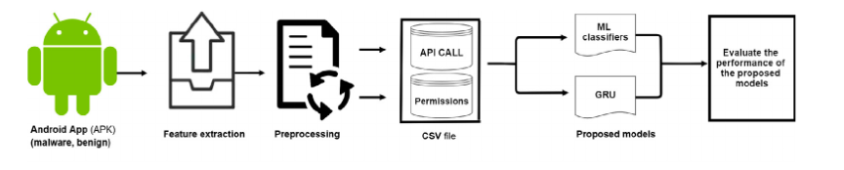
- System architecture
DATA FLOW DIAGRAM:

The DFD is also called as bubble chart. It is a simple graphical formalism that can be used to represent a system in terms of input data to the system, various processing carried out on this data, and the output data is generated by this system.
The data flow diagram (DFD) is one of the most important modeling tools. It is used to model the system components. These components are the system process, the data used by the process, an external entity that interacts with the system and the information flows in the system.

NO PROCESS
VERIFY

Import libraries
YES NO
Exploring the dataset

Preprocess data
Data processing

Split data
Train and validation

Initialize algorithm
Train model with vgg 19 and show accuracy and loss graph

Training the model
Signup & signin

User input
Final outcome
End process

- Data flow diagram

5.2 UML DIAGRAMS

UML stands for Unified Modeling Language. UML is a standardized general-purpose modeling language in the field of object-oriented software engineering. The standard is managed, and was created by, the Object Management Group.
The goal is for UML to become a common language for creating models of object oriented computer software. In its current form UML is comprised of two major components: a Meta-model and a notation. In the future, some form of method or process may also be added to; or associated with, UML.
The Unified Modeling Language is a standard language for specifying, Visualization, Constructing and documenting the artifacts of software system, as well as for business modeling and other non-software systems.
The UML represents a collection of best engineering practices that have proven successful in the modeling of large and complex systems.
The UML is a very important part of developing objects oriented software and the software development process. The UML uses mostly graphical notations to express the design of software projects.

GOALS:
The Primary goals in the design of the UML are as follows:
Provide users a ready-to-use, expressive visual modeling Language so that they can develop and exchange meaningful models.
Provide extendibility and specialization mechanisms to extend the core concepts.
Be independent of particular programming languages and development process.
Provide a formal basis for understanding the modeling language.
Encourage the growth of OO tools market.
Support higher level development concepts such as collaborations, frameworks, patterns and components.
Integrate best practices.

Use case diagram:
A use case diagram in the Unified Modeling Language (UML) is a type of behavioral diagram defined by and created from a Use-case analysis. Its purpose is to present a graphical overview of the functionality provided by a system in terms of actors, their goals (represented as use cases), and any dependencies between those use cases. The main purpose of a use case diagram is to show what system functions are performed for which actor. Roles of the actors in the system can be depicted.
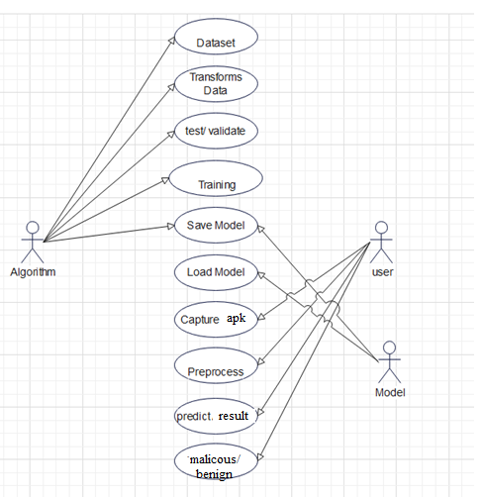
- Use case diagram
Class diagram:
The class diagram is used to refine the use case diagram and define a detailed design of the system. The class diagram classifies the actors defined in the use case diagram into a set of interrelated classes. The relationship or association between the classes can be either an "is-a" or "has-a" relationship. Each class in the class diagram may be capable of providing certain functionalities. These functionalities provided by the class are termed "methods" of the class. Apart from this, each class may have certain "attributes" that uniquely identify the class.
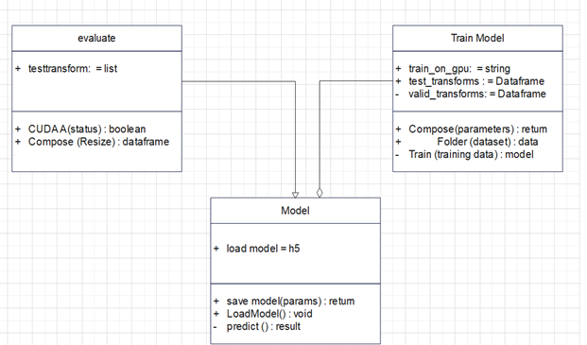
- Class diagram

Activity diagram:
The process flows in the system are captured in the activity diagram. Similar to a state diagram, an activity diagram also consists of activities, actions, transitions, initial and final states, and guard conditions.
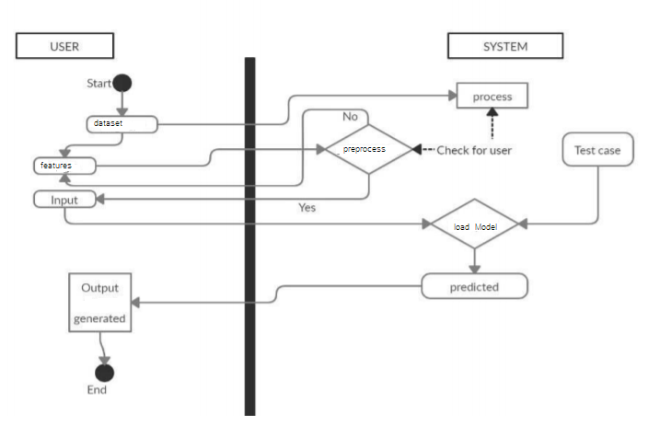
- Activity diagram

Sequence diagram:
A sequence diagram represents the interaction between different objects in the system. The important aspect of a sequence diagram is that it is time-ordered. This means that the exact sequence of the interactions between the objects is represented step by step. Different objects in the sequence diagram interact with each other by passing "messages".
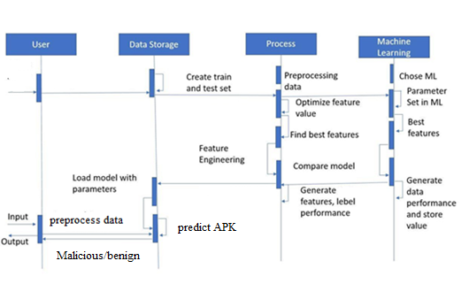
- Sequence diagram

Collaboration diagram:
A collaboration diagram groups together the interactions between different objects. The interactions are listed as numbered interactions that help to trace the sequence of the interactions. The collaboration diagram helps to identify all the possible interactions that each object has with other objects.
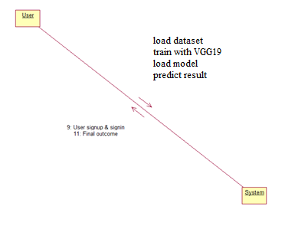
- Collaboration diagram

Component diagram:
The component diagram represents the high-level parts that make up the system. This diagram depicts, at a high level, what components form part of the system and how they are interrelated. A component diagram depicts the components culled after the system has undergone the development or construction phase.
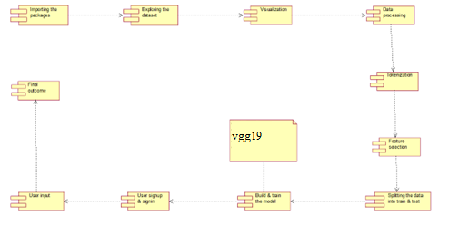
- Component diagram

Deployment diagram:
The deployment diagram captures the configuration of the runtime elements of the application. This diagram is by far most useful when a system is built and ready to be deployed.
- Deployment diagram
- .METHODOLOGY
MODULES:

Data COLLECTION:
In our experiments, we utilized the Drebin dataset [3] as the source of Android malware. Moreover, we also download benign apps from Google play for comparison purpose. In the experiments, we calculated the similarity score in terms of the 31 dangerous API calls that we identified between 400 Android apps (in which 200 are benign, and 200 are malware) for the training stage of SVM model. In addition, based on the scanning results of the same 400 Android apps, we found that in these 400 applications, 180 of them have some particular sets of risky permissions. Thus, we chose to use the risky permission sets as the additional features in the feature vector for SVM model.

Train-Test Split and Model FITTING:

Now, we divide our dataset into training and testing data. Our objective for doing this split is to assess the performance of our model on unseen data and to determine how well our model has generalized on training data. This is followed by a model fitting which is an essential step in the model building process.

Model Evaluation and Predictions:
There are three major components in the malware detection scheme, namely decoder (decomplication), feature extraction, and classifier. In the decomplication component, each Android app is unpacked and decoded into a readable small file. Some key features, such as risky permissions, suspicious API calls, and URLs are then extracted in feature extraction components according to several important and widely accepted measures, such as TF-IDF and cosine similarity. Finally, we use machine learning algorithm to build a classification model and evaluate them on the Android app dataset by classifying them into malware or benign app.
Algorithms

Support Vector Machine
A support vector machine (SVM) is a type of supervised machine learning classification algorithm which outputs an optimal hyperplane that categorizes new examples given labeled training data [15]. SVMs were introduced initially in 1960s and were later refined in 1990s. However, it is only now that they are becoming very popular, owing to their ability to achieve outstanding results.
Simple SVM: In case of linearly separable data in two dimensions, as shown in Figure 2.6, a typical machine learning algorithm tries to find a boundary that divides the data in such a way that the misclassification error can be minimized. If you closely look at Figure 2.6, there can be several boundaries that correctly divide the data points. The two dashed lines as well as one solid line classify the data correctly.

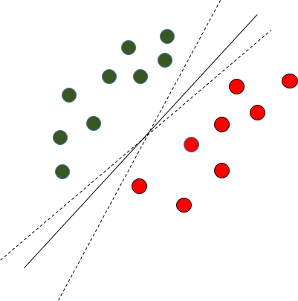

Fig. 2.6 Multiple Decision Boundaries

SVM differs from the other classification algorithms in the way that it chooses the decision boundary that maximizes the distance from the nearest data points of all the classes. An SVM doesn’t merely find a decision boundary; it finds the most optimal decision boundary. The most optimal decision boundary is the one which has maximum margin from the nearest points of all the classes. The nearest points from the decision boundary that maximize the distance between the decision boundary and the points are called support vectors as seen in Figure¬2.7. The decision boundary in case of support vector machines is called the maximum margin classifier, or the maximum margin hyper plane.
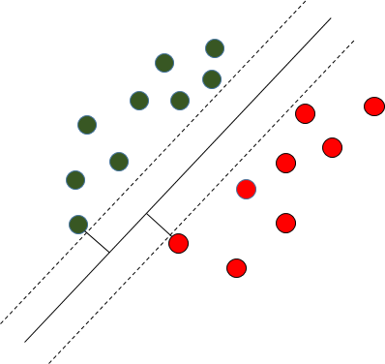
Fig. 2.7 Decision Boundary with Support Vectors

Kernel SVM: In the previous two figures Figure 2.6 and Figure 2.7 it was shown how the simple SVM algorithm can be used to find decision boundary for linearly separable data. However, in the case of non-linearly separable data, such as the one shown in Figure 2.8, a straight line cannot be used as a decision boundary.
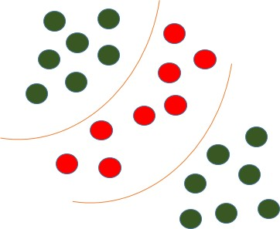
Fig. 2.8 Non-linearly Separable Data

In case of non-linearly separable data, the simple SVM algorithm cannot be used. Rather, a modified version of SVM, called Kernel SVM, is used. Basically, the kernel SVM projects the non-linearly separable data lower dimensions to linearly separable data in higher dimen- sions in such a way that data points belonging to different classes are allocated to different dimensions.

Neural Network:
An Artificial Neural Network in the field of Artificial intelligence where it attempts to mimic the network of neurons makes up a human brain so that computers will have an option to understand things and make decisions in a human-like manner. The artificial neural network is designed by programming computers to behave simply like interconnected brain cells.
There are around 1000 billion neurons in the human brain. Each neuron has an association point somewhere in the range of 1,000 and 100,000. In the human brain, data is stored in such a manner as to be distributed, and we can extract more than one piece of this data when necessary from our memory parallelly. We can say that the human brain is made up of incredibly amazing parallel processors.
We can understand the artificial neural network with an example, consider an example of a digital logic gate that takes an input and gives an output. "OR" gate, which takes two inputs. If one or both the inputs are "On," then we get "On" in output. If both the inputs are "Off," then we get "Off" in output. Here the output depends upon input. Our brain does not perform the same task. The outputs to inputs relationship keep changing because of the neurons in our brain, which are "learning."
The architecture of an artificial neural network:
To understand the concept of the architecture of an artificial neural network, we have to understand what a neural network consists of. In order to define a neural network that consists of a large number of artificial neurons, which are termed units arranged in a sequence of layers. Lets us look at various types of layers available in an artificial neural network.
Artificial Neural Network primarily consists of three layers:
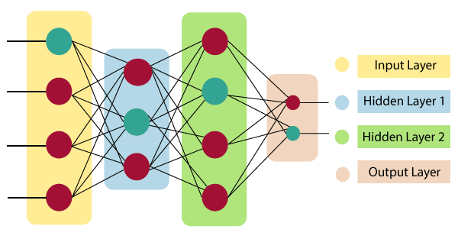
Input Layer:
As the name suggests, it accepts inputs in several different formats provided by the programmer.
Hidden Layer:
The hidden layer presents in-between input and output layers. It performs all the calculations to find hidden features and patterns.
Output Layer:
The input goes through a series of transformations using the hidden layer, which finally results in output that is conveyed using this layer.
The artificial neural network takes input and computes the weighted sum of the inputs and includes a bias. This computation is represented in the form of a transfer function.
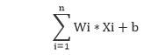
It determines weighted total is passed as an input to an activation function to produce the output. Activation functions choose whether a node should fire or not. Only those who are fired make it to the output layer. There are distinctive activation functions available that can be applied upon the sort of task we are performing.
(6) Model testing. Extract the data from input image pictures from the data set as
the test sample set for model testing, and predict result..
6.2 SAMPLE CODE:
from tkinter import messagebox
from tkinter import *
from tkinter import simpledialog
import tkinter
from tkinter import filedialog
import matplotlib.pyplot as plt
from tkinter.filedialog import askopenfilename
from CustomButton import TkinterCustomButton
from sklearn.model_selection import train_test_split
from sklearn.metrics import precision_score
from sklearn.metrics import recall_score
from sklearn.metrics import f1_score
from sklearn.metrics import accuracy_score
import pandas as pd
import numpy as np
import pickle
import os
from keras.models import Sequential, Model
from keras.layers import Dense, Dropout, Activation, Embedding, LSTM
import numpy as np
from sklearn.preprocessing import LabelEncoder
from string import punctuation
from nltk.corpus import stopwords
import nltk
from nltk.stem import WordNetLemmatizer
from sklearn.feature_extraction.text import TfidfVectorizer
from sklearn.svm import LinearSVC
from sklearn.linear_model import LogisticRegression
from sklearn.naive_bayes import MultinomialNB
from sklearn.neural_network import MLPClassifier
from sklearn.linear_model import SGDClassifier
from sklearn.linear_model import RidgeClassifier
from numpy import dot
from numpy.linalg import norm
import sklearn
import pickle
import pandas as pd
from sklearn.svm import SVC
from sklearn.model_selection import train_test_split, GridSearchCV
from sklearn.metrics import classification_report, confusion_matrix
import classifier
main = Tk()
main.title("Fraud Malware APP Detection Using ML and DL")
main.geometry("1300x1200")
global filename
global dataset
global X, Y
global X_train, X_test, y_train, y_test
accuracy = []
precision = []
recall = []
fscore = []

stop_words = set(stopwords.words('english'))
lemmatizer = WordNetLemmatizer()
global drug_name, condition, review, rating
global tfidf_vectorizer
global classifier
def cleanPost(doc):
tokens = doc.split()
table = str.maketrans('', '', punctuation)
tokens = [w.translate(table) for w in tokens]
tokens = [word for word in tokens if word.isalpha()]
tokens = [w for w in tokens if not w in stop_words]
tokens = [word for word in tokens if len(word) > 1]
tokens = [lemmatizer.lemmatize(token) for token in tokens]
tokens = ' '.join(tokens)
return tokens
def uploadDataset():
global filename
global dataset
text.delete('1.0', END)
filename = askopenfilename(initialdir = "Dataset")
tf1.insert(END,str(filename))
text.insert(END,"Dataset Loaded\n\n")
dataset = pd.read_csv(filename,'r')
text.insert(END,str(dataset.head()))
def preprocessDataset():
text.delete('1.0', END)
global X, Y
global X_train, X_test, y_train, y_test
global dataset
text.delete('1.0', END)
dataset_df = pd.read_csv('android_dataset.csv')
Y = dataset_df['class']
X = dataset_df.drop(['class'], axis=1)
X_train, X_test, y_train, y_test = train_test_split(X, Y, test_size=0.2)
text.insert(END,"Train & Test Model Generated\n\n")
text.insert(END,"Total Dataset Size : "+str(len(X))+"\n")
text.insert(END,"Split Training Size : "+str(len(X_train))+"\n")
text.insert(END,"Split Test Size : "+str(len(X_test))+"\n")
def TFIDFExtraction():
text.delete('1.0', END)
global X, Y
global X_train, X_test, y_train, y_test
param_grid = {'C': [0.1, 1, 10, 100, 1000],
'gamma': [1, 0.1, 0.01, 0.001, 0.0001],
'kernel': ['rbf']}
grid = GridSearchCV(SVC(), param_grid, refit = True, verbose = 3)

# fitting the model for grid search
grid.fit(X_train, y_train)
print(grid.best_params_)
grid_predictions = grid.predict(X_test)
test(grid,"SVM")
# print classification report
#print(classification_report(y_test, grid_predictions))
text.insert(END,"Classification Report for SVM\n\n")
text.insert(END,str(classification_report(y_test, grid_predictions))+"\n")
def test(cls,name):
predict = cls.predict(X_test)
acc = accuracy_score(y_test,predict)*100
p = precision_score(y_test,predict,average='macro') * 100
r = recall_score(y_test,predict,average='macro') * 100
f = f1_score(y_test,predict,average='macro') * 100
text.insert(END,name+" Precision : "+str(p)+"\n")
text.insert(END,name+" Recall : "+str(r)+"\n")
text.insert(END,name+" F1-Score : "+str(f)+"\n")
text.insert(END,name+" Accuracy : "+str(acc)+"\n\n")
precision.append(p)
accuracy.append(acc)
recall.append(r)
fscore.append(f)
def TrainML():
text.delete('1.0', END)
global X, Y
global X_train, X_test, y_train, y_test
encoder = LabelEncoder().fit(Y)
Y = encoder.transform(Y)
#print(encoder.transform(['malign']))
X_train, X_test, y_train, y_test = train_test_split(X, Y, test_size=0.2)
text.delete('1.0', END)
AN = Sequential()
AN.add(Dense(256, activation='relu', input_dim=428))
AN.add(Dropout(0.2))
AN.add(Dense(128, activation='relu'))
AN.add(Dropout(0.2))
AN.add(Dense(128, activation='relu'))
AN.add(Dropout(0.2))
AN.add(Dense(32, activation='relu'))
AN.add(Dropout(0.2))
AN.add(Dense(1, activation='sigmoid'))
AN.compile(optimizer='sgd', loss='binary_crossentropy', metrics=['accuracy'])

AN.fit(X_train, y_train, epochs=100, batch_size=32)
#test(AN,"ANN")
scores = AN.evaluate(X_test, y_test)
text.insert(END,"Accuracy and Loss ANN Algorihtm\n\n")
for i in range(len(scores)):
text.insert(END,str((AN.metrics_names[i], scores[i]*100))+"\n")
def graph():
accuracy.append(88.69047619047619)
accuracy.append(91.66666865348816)
df = pd.DataFrame([['SVM','Accuracy',accuracy[0]],
['ANN','Accuracy',accuracy[1]]
],columns=['Parameters','Algorithms','Value'])
df.pivot("Parameters", "Algorithms", "Value").plot(kind='bar')
plt.show()
def recommendDrug():
text.delete('1.0', END)
text.delete('1.0', END)
global X
global drug_name, condition, review, rating
global classifier
global tfidf_vectorizer
filename1 = askopenfilename(initialdir = "input")
result, name, sdk, size = classifier.classify(filename1, 0)
tf1.insert(END,str(filename))
text.insert(END,"Prediction Result: "+str(result)+"\n")
text.insert(END,"Apk Name: "+str(name)+"\n")
text.insert(END,"SDK Version: "+str(sdk)+"\n\n")
text.insert(END,"APK Size: "+str(size)+"\n\n")
font = ('times', 15, 'bold')
title = Label(main, text='Fraud Malware APP Detection Using ML and DL')
title.config(bg='HotPink4', fg='yellow2')
title.config(font=font)
title.config(height=3, width=120)
title.place(x=0,y=5)
font1 = ('times', 13, 'bold')
ff = ('times', 12, 'bold')
l1 = Label(main, text='Dataset Location:')
l1.config(font=font1)
l1.place(x=50,y=100)

tf1 = Entry(main,width=60)
tf1.config(font=font1)
tf1.place(x=230,y=100)
uploadButton = TkinterCustomButton(text="Upload Fraud APP Dataset", width=300, corner_radius=5, command=uploadDataset)
uploadButton.place(x=50,y=150)
preprocessButton = TkinterCustomButton(text="Split Dataset", width=300, corner_radius=5, command=preprocessDataset)
preprocessButton.place(x=400,y=150)
tfidfButton = TkinterCustomButton(text="Training SVM Algorihtm", width=300, corner_radius=5, command=TFIDFExtraction)
tfidfButton.place(x=790,y=150)
trainMLButton = TkinterCustomButton(text="Train ANN Algorihtm", width=300, corner_radius=5, command=TrainML)
trainMLButton.place(x=50,y=200)
graphButton = TkinterCustomButton(text="Comparison Graph", width=300, corner_radius=5, command=graph)
graphButton.place(x=400,y=200)
predictButton = TkinterCustomButton(text="Upload APK", width=300, corner_radius=5, command=recommendDrug)
predictButton.place(x=790,y=200)
font1 = ('times', 13, 'bold')
text=Text(main,height=20,width=130)
scroll=Scrollbar(text)
text.configure(yscrollcommand=scroll.set)
text.place(x=10,y=250)
text.config(font=font1)
main.config(bg='plum2')
main.mainloop()

7. SOFTWARE ENVIRONMENT

What is Anaconda for Python?
Anaconda software helps you create an environment for many different versions of Python and package versions. Anaconda is also used to install, remove, and upgrade packages in your project environments. Furthermore, you may use Anaconda to deploy any required project with a few mouse clicks. This is why it is perfect for beginners who want to learn Python.
Now that you know what Anaconda Python is, let's look at how to install it.

How to install Anaconda for Python?

To install Anaconda, just head to the Anaconda Documentation website and follow the instructions to download the installer for your operating system. Once the installer successfully downloads, double-click on it to start the installation process.
Follow the prompts and agree to the terms and conditions. When you are asked if you want to "add Anaconda to my PATH environment variable," make sure that you select "yes." This will ensure that Anaconda is added to your system's PATH, which is a list of directories that your operating system uses to find the files it needs.
Once the installation is complete, you will be asked if you want to "enable Anaconda as my default Python." We recommend selecting "yes" to use Anaconda as your default Python interpreter.

Python Anaconda Installation
Next in the Python anaconda tutorial is its installation. The latest version of Anaconda at the time of writing is 2019.10. Follow these steps to download and install Anaconda on your machine:
1. Go to this link and download Anaconda for Windows, Mac, or Linux: – Download anaconda

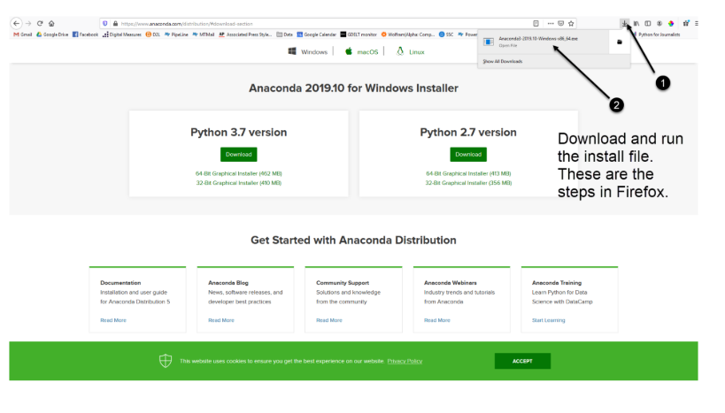
- Anaconda installation
You can download the installer for Python 3.7 or for Python 2.7 (at the time of writing). And you can download it for a 32-bit or 64-bit machine.
2. Click on the downloaded .exe to open it. This is the Anaconda setup. Click next.

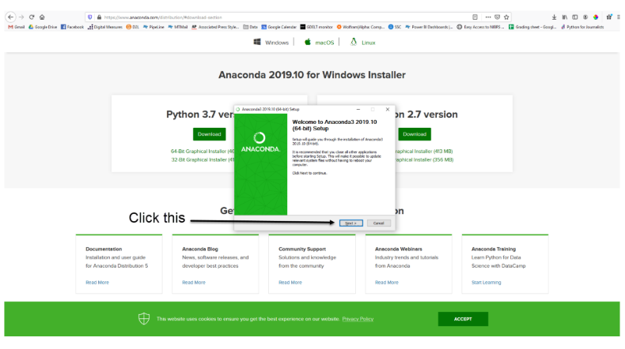
- Anaconda setup
3. Now, you’ll see the license agreement. Click on ‘I Agree’.

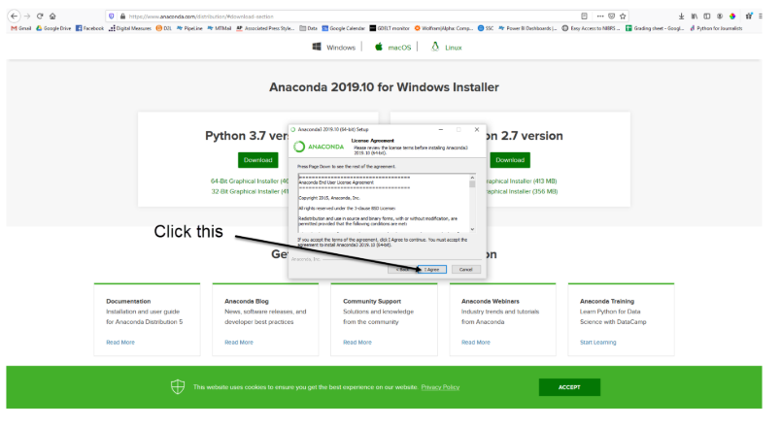
- License agreement

5. Now, you’ll get some advanced options. You can add Anaconda to your system’s PATH environment variable, and register it as the primary system Python 3.7. If you add it to PATH, it will be found before any other installation. Click on ‘Install’.
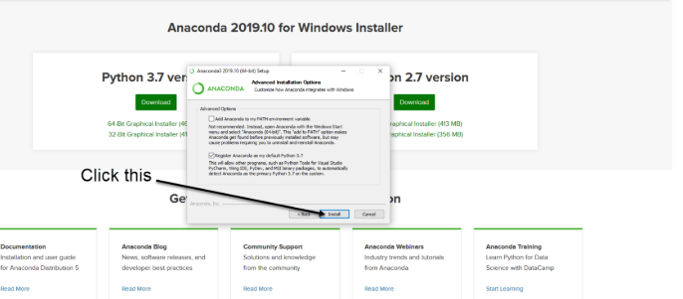
- Installation of anaconda
6. It will unpack some packages and extract some files on your machine. This will take a few minutes.
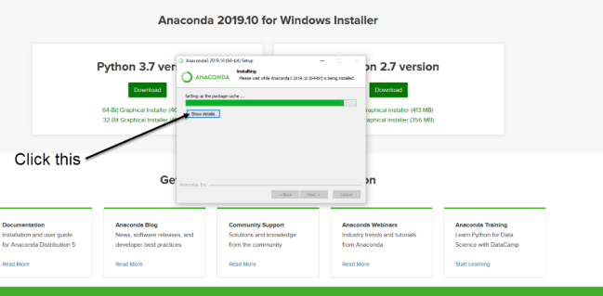
- packages

7. The installation is complete. Click Next.
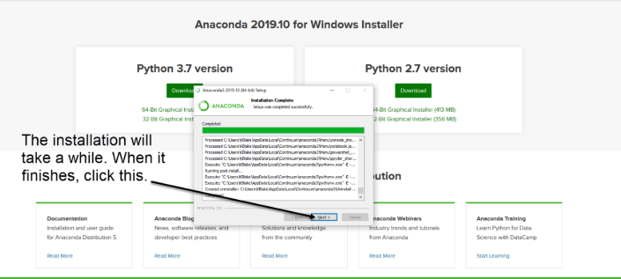
- completion of installation
8. The installation is complete. You can choose to get more information about Anaconda cloud and how to get started with Anaconda. Click Finish.
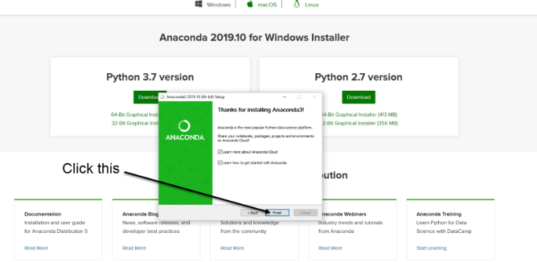
- finish setup

PYTHON LANGUAGE:
Python is an interpreted, object-oriented, high-level programming language with dynamic semantics. Its high-level built in data structures, combined with dynamic typing and dynamic binding, make it very attractive for Rapid Application Development, as well as for use as a scripting or glue language to connect existing components together. Python's simple, easy to learn syntax emphasizes readability and therefore reduces the cost of program maintenance. Python supports modules and packages, which encourages program modularity and code reuse. The Python interpreter and the extensive standard library are available in source or binary form without charge for all major platforms, and can be freely distributed. Often, programmers fall in love with Python because of the increased productivity it provides. Since there is no compilation step, the edit-test-debug cycle is incredibly fast. Debugging Python programs is easy: a bug or bad input will never cause a segmentation fault. Instead, when the interpreter discovers an error, it raises an exception. When the program doesn't catch the exception, the interpreter prints a stack trace. A source level debugger allows inspection of local and global variables, evaluation of arbitrary expressions, setting breakpoints, stepping through the code a line at a time, and so on. The debugger is written in Python itself, testifying to Python's introspective power. On the other hand, often the quickest way to debug a program is to add a few print statements to the source: the fast edit-test-debug cycle makes this simple approach very effective.
Python is a dynamic, high-level, free open source, and interpreted programming language. It supports object-oriented programming as well as procedural-oriented programming. In Python, we don’t need to declare the type of variable because it is a dynamically typed language. For example, x = 10 Here, x can be anything such as String, int, etc.

Features in Python:
There are many features in Python, some of which are discussed below as follows:

1. Free and Open Source
Python language is freely available at the official website and you can download it from the given download link below click on the Download Python keyword. Download Python Since it is open-source, this means that source code is also available to the public. So you can download it, use it as well as share it.

2. Easy to code
Python is a high-level programming language. Python is very easy to learn the language as compared to other languages like C, C#, Javascript, Java, etc. It is very easy to code in the Python language and anybody can learn Python basics in a few hours or days. It is also a developer-friendly language.

3. Easy to Read
As you will see, learning Python is quite simple. As was already established, Python’s syntax is really straightforward. The code block is defined by the indentations rather than by semicolons or brackets.

4. Object-Oriented Language
One of the key features of python is object oriented . Python supports object-oriented language and concepts of classes, object encapsulation, etc.

5. GUI Programming Support
Graphical User interfaces can be made using a module such as PyQt5 , PyQt4, wxPython, or Tk in python. PyQt5 is the most popular option for creating graphical apps with Python.

6. High-Level Language
Python is a high-level language. When we write programs in Python, we do not need to remember the system architecture, nor do we need to manage the memory.

7. Extensible feature
Python is an Extensible language. We can write some Python code into C or C++ language and also we can compile that code in C/C++ language.

8. Easy to Debug
Excellent information for mistake tracing. You will be able to quickly identify and correct the majority of your program’s issues once you understand how to Python’s error traces. Simply by glancing at the code, you can determine what it is designed to perform.

9. Python is a Portable language
Python language is also a portable language. For example, if we have Python code for windows and if we want to run this code on other platforms such as linux , Unix, and Mac then we do not need to change it, we can run this code on any platform.

10. Python is an Integrated language
Python is also an Integrated language because we can easily integrate Python with other languages like C, C++, etc.

11. Interpreted Language:
Python is an Interpreted Language because Python code is executed line by line at a time. like other languages C, C++, Java, etc. there is no need to compile Python code this makes it easier to debug our code. The source code of Python is converted into an immediate form called bytecode.

12. Large Standard Library
Python has a large standard library that provides a rich set of modules and functions so you do not have to write your own code for every single thing. There are many libraries present in Python such as regular expressions, unit-testing, web browsers, etc.

13. Dynamically Typed Language
Python is a dynamically-typed language. That means the type (for example- int, double, long, etc.) for a variable is decided at run time not in advance because of this feature we don’t need to specify the type of variable.

14. Frontend and backend development
With a new project py script, you can run and write Python codes in HTML with the help of some simple tags <py-script>, <py-env>, etc. This will help you do frontend development work in Python like javascript. Backend is the strong forte of Python it’s extensively used for this work cause of its frameworks like Django and Flask.

15. Allocating Memory Dynamically
In Python, the variable data type does not need to be specified. The memory is automatically allocated to a variable at runtime when it is given a value. Developers do not need to write int y = 18 if the integer value 15 is set to y. You may just type y=18.
What is Machine Learning : -
Before we take a look at the details of various machine learning methods, let's start by looking at what machine learning is, and what it isn't. Machine learning is often categorized as a subfield of artificial intelligence, but I find that categorization can often be misleading at first brush. The study of machine learning certainly arose from research in this context, but in the data science application of machine learning methods, it's more helpful to think of machine learning as a means of building models of data.
Fundamentally, machine learning involves building mathematical models to help understand data. "Learning" enters the fray when we give these models tunable parameters that can be adapted to observed data; in this way the program can be considered to be "learning" from the data. Once these models have been fit to previously seen data, they can be used to predict and understand aspects of newly observed data. I'll leave to the reader the more philosophical digression regarding the extent to which this type of mathematical, model-based "learning" is similar to the "learning" exhibited by the human brain.Understanding the problem setting in machine learning is essential to using these tools effectively, and so we will start with some broad categorizations of the types of approaches we'll discuss here.
Categories Of Machine Leaning :-
At the most fundamental level, machine learning can be categorized into two main types: supervised learning and unsupervised learning.
Supervised learning involves somehow modeling the relationship between measured features of data and some label associated with the data; once this model is determined, it can be used to apply labels to new, unknown data. This is further subdivided into classification tasks and regression tasks: in classification, the labels are discrete categories, while in regression, the labels are continuous quantities. We will see examples of both types of supervised learning in the following section.
Unsupervised learning involves modeling the features of a dataset without reference to any label, and is often described as "letting the dataset speak for itself." These models include tasks such as clustering and dimensionality reduction. Clustering algorithms identify distinct groups of data, while dimensionality reduction algorithms search for more succinct representations of the data. We will see examples of both types of unsupervised learning in the following section.

Need for Machine Learning
Human beings, at this moment, are the most intelligent and advanced species on earth because they can think, evaluate and solve complex problems. On the other side, AI is still in its initial stage and haven’t surpassed human intelligence in many aspects. Then the question is that what is the need to make machine learn? The most suitable reason for doing this is, “to make decisions, based on data, with efficiency and scale”.
Lately, organizations are investing heavily in newer technologies like Artificial Intelligence, Machine Learning and Deep Learning to get the key information from data to perform several real-world tasks and solve problems. We can call it data-driven decisions taken by machines, particularly to automate the process. These data-driven decisions can be used, instead of using programing logic, in the problems that cannot be programmed inherently. The fact is that we can’t do without human intelligence, but other aspect is that we all need to solve real-world problems with efficiency at a huge scale. That is why the need for machine learning arises.

Challenges in Machines Learning :-

While Machine Learning is rapidly evolving, making significant strides with cybersecurity and autonomous cars, this segment of AI as whole still has a long way to go. The reason behind is that ML has not been able to overcome number of challenges. The challenges that ML is facing currently are −
Quality of data − Having good-quality data for ML algorithms is one of the biggest challenges. Use of low-quality data leads to the problems related to data preprocessing and feature extraction.
Time-Consuming task − Another challenge faced by ML models is the consumption of time especially for data acquisition, feature extraction and retrieval.
Lack of specialist persons − As ML technology is still in its infancy stage, availability of expert resources is a tough job.
No clear objective for formulating business problems − Having no clear objective and well-defined goal for business problems is another key challenge for ML because this technology is not that mature yet.
Issue of overfitting & underfitting − If the model is overfitting or underfitting, it cannot be represented well for the problem.
Curse of dimensionality − Another challenge ML model faces is too many features of data points. This can be a real hindrance.
Difficulty in deployment − Complexity of the ML model makes it quite difficult to be deployed in real life.

What is deep learning?
Deep learning is a subset of machine learning, which is essentially a neural network with three or more layers. These neural networks attempt to simulate the behavior of the human brain—albeit far from matching its ability—allowing it to “learn” from large amounts of data. While a neural network with a single layer can still make approximate predictions, additional hidden layers can help to optimize and refine for accuracy.

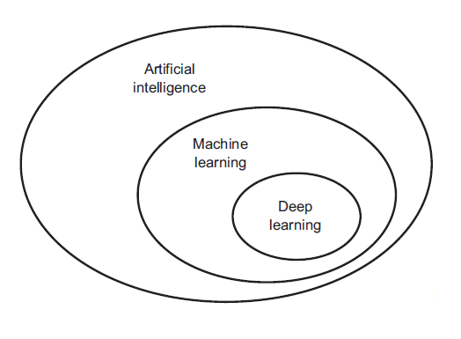
- Deep learning
Deep learning drives many artificial intelligence (AI) applications and services that improve automation, performing analytical and physical tasks without human intervention. Deep learning technology lies behind everyday products and services (such as digital assistants, voice-enabled TV remotes, and credit card fraud detection) as well as emerging technologies (such as self-driving cars).

How deep learning works
Deep learning neural networks, or artificial neural networks, attempts to mimic the human brain through a combination of data inputs, weights, and bias. These elements work together to accurately recognize, classify, and describe objects within the data.
Deep neural networks consist of multiple layers of interconnected nodes, each building upon the previous layer to refine and optimize the prediction or categorization. This progression of computations through the network is called forward propagation. The input and output layers of a deep neural network are called visible layers. The input layer is where the deep learning model ingests the data for processing, and the output layer is where the final prediction or classification is made.

Another process called backpropagation uses algorithms, like gradient descent, to calculate errors in predictions and then adjusts the weights and biases of the function by moving backwards through the layers in an effort to train the model. Together, forward propagation and backpropagation allow a neural network to make predictions and correct for any errors accordingly. Over time, the algorithm becomes gradually more accurate.
The above describes the simplest type of deep neural network in the simplest terms. However, deep learning algorithms are incredibly complex, and there are different types of neural networks to address specific problems or datasets. For example,
- Convolutional neural networks (CNNs), used primarily in computer vision and image classification applications, can detect features and patterns within an image, enabling tasks, like object detection or recognition. In 2015, a CNN bested a human in an object recognition challenge for the first time.
- Recurrent neural network (RNNs) are typically used in natural language and speech recognition applications as it leverages sequential or times series data.

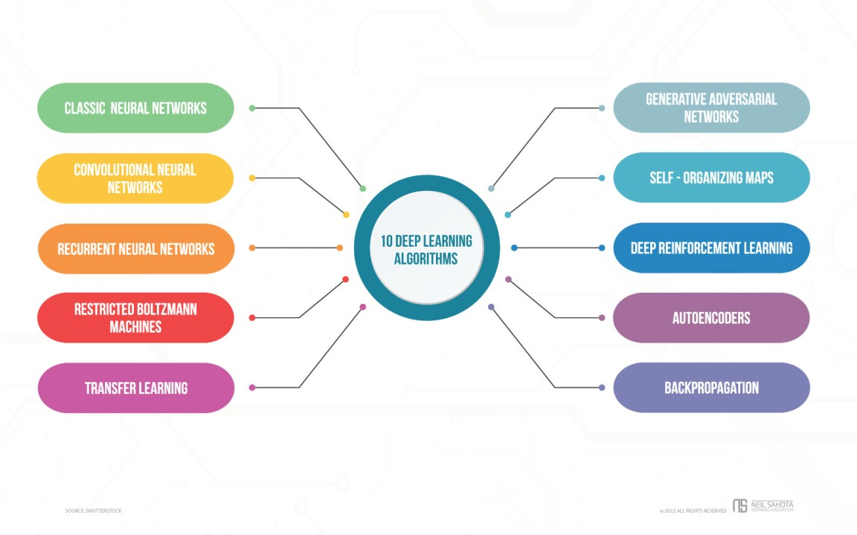
- Deep learning alogorithms

LIBRARIES/PACKGES :-
Tensorflow
TensorFlow is a free and open-source software library for dataflow and differentiable programming across a range of tasks. It is a symbolic math library, and is also used for machine learning applications such as neural networks. It is used for both research and production at Google.‍
TensorFlow was developed by the Google Brain team for internal Google use. It was released under the Apache 2.0 open-source license on November 9, 2015.

Numpy
Numpy is a general-purpose array-processing package. It provides a high-performance multidimensional array object, and tools for working with these arrays.
It is the fundamental package for scientific computing with Python. It contains various features including these important ones:
- A powerful N-dimensional array object
- Sophisticated (broadcasting) functions
- Tools for integrating C/C++ and Fortran code
- Useful linear algebra, Fourier transform, and random number capabilities
Besides its obvious scientific uses, Numpy can also be used as an efficient multi-dimensional container of generic data. Arbitrary data-types can be defined using Numpy which allows Numpy to seamlessly and speedily integrate with a wide variety of databases.
Pandas
Pandas is an open-source Python Library providing high-performance data manipulation and analysis tool using its powerful data structures. Python was majorly used for data munging and preparation. It had very little contribution towards data analysis. Pandas solved this problem. Using Pandas, we can accomplish five typical steps in the processing and analysis of data, regardless of the origin of data load, prepare, manipulate, model, and analyze. Python with Pandas is used in a wide range of fields including academic and commercial domains including finance, economics, Statistics, analytics, etc.
Matplotlib
Matplotlib is a Python 2D plotting library which produces publication quality figures in a variety of hardcopy formats and interactive environments across platforms. Matplotlib can be used in Python scripts, the Python and IPython shells, the Jupyter Notebook, web application servers, and four graphical user interface toolkits. Matplotlib tries to make easy things easy and hard things possible. You can generate plots, histograms, power spectra, bar charts, error charts, scatter plots, etc., with just a few lines of code. For examples, see the sample plots and thumbnail gallery.
For simple plotting the pyplot module provides a MATLAB-like interface, particularly when combined with IPython. For the power user, you have full control of line styles, font properties, axes properties, etc, via an object oriented interface or via a set of functions familiar to MATLAB users.
Scikit – learn
Scikit-learn provides a range of supervised and unsupervised learning algorithms via a consistent interface in Python. It is licensed under a permissive simplified BSD license and is distributed under many Linux distributions, encouraging academic and commercial use.

8. SYSTEM TESTING
System testing, also referred to as system-level tests or system-integration testing, is the process in which a quality assurance (QA) team evaluates how the various components of an application interact together in the full, integrated system or application. System testing verifies that an application performs tasks as designed. This step, a kind of black box testing, focuses on the functionality of an application. System testing, for example, might check that every kind of user input produces the intended output across the application.
Phases of system testing:
A video tutorial about this test level. System testing examines every component of an application to make sure that they work as a complete and unified whole. A QA team typically conducts system testing after it checks individual modules with functional or user-story testing and then each component through integration testing.
If a software build achieves the desired results in system testing, it gets a final check via acceptance testing before it goes to production, where users consume the software. An app-dev team logs all defects, and establishes what kinds and amount of defects are tolerable.
8.1Software Testing Strategies:
Optimization of the approach to testing in software engineering is the best way to make it effective. A software testing strategy defines what, when, and how to do whatever is necessary to make an end-product of high quality. Usually, the following software testing strategies and their combinations are used to achieve this major objective:
Static Testing:
The early-stage testing strategy is static testing: it is performed without actually running the developing product. Basically, such desk-checking is required to detect bugs and issues that are present in the code itself. Such a check-up is important at the pre-deployment stage as it helps avoid problems caused by errors in the code and software structure deficits.
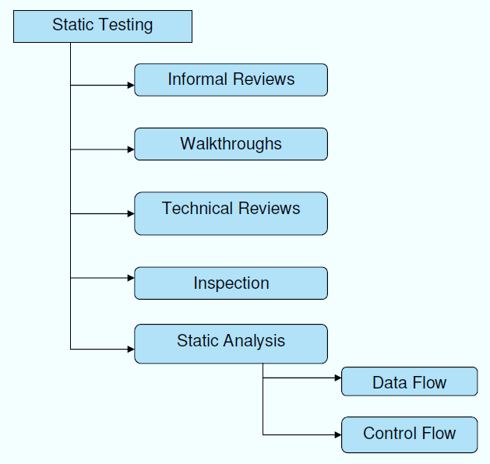
- Static testing

Structural Testing:
It is not possible to effectively test software without running it. Structural testing, also known as white-box testing, is required to detect and fix bugs and errors emerging during the pre-production stage of the software development process. At this stage, unit testing based on the software structure is performed using regression testing. In most cases, it is an automated process working within the test automation framework to speed up the development process at this stage. Developers and QA engineers have full access to the software’s structure and data flows (data flows testing), so they could track any changes (mutation testing) in the system’s behavior by comparing the tests’ outcomes with the results of previous iterations (control flow testing).
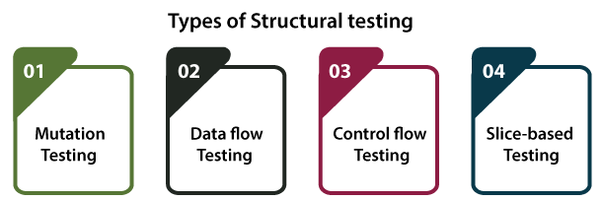
- Types of structural testing
Behavioral Testing:
The final stage of testing focuses on the software’s reactions to various activities rather than on the mechanisms behind these reactions. In other words, behavioral testing, also known as black-box testing, presupposes running numerous tests, mostly manual, to see the product from the user’s point of view. QA engineers usually have some specific information about a business or other purposes of the software (‘the black box’) to run usability tests, for example, and react to bugs as regular users of the product will do.
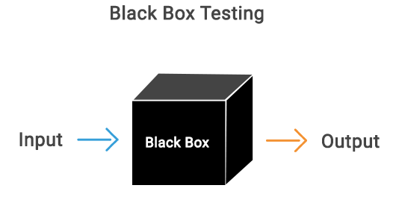

S.NO | INPUT | If available | If not available
1 | User signup | User get registered into the application | There is no process
2 | User signin | User get login into the application | There is no process
3 | Enter input for prediction | Prediction result displayed | There is no process
- Blackbox testing
8.2 TEST CASES:
- Test cases table

- SCREENSHOTS
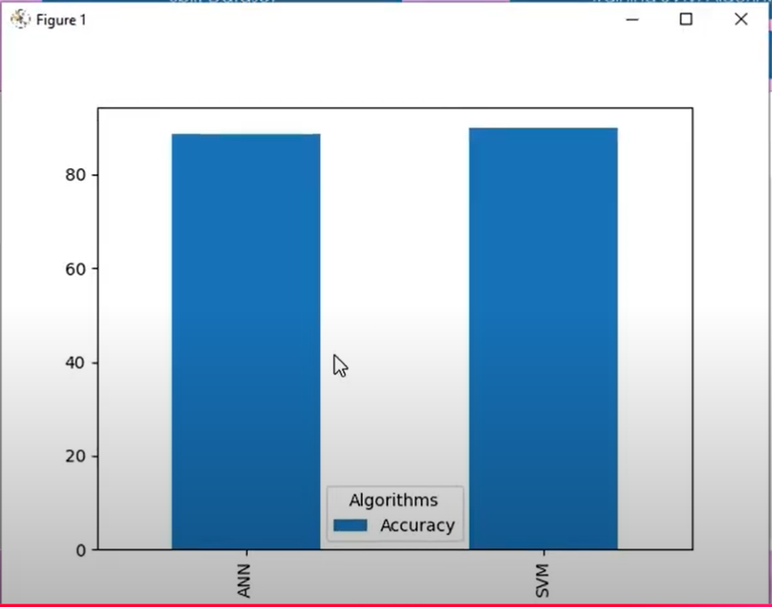

- ACCURACY COMPARISON GRAPHS OF CBET
DATASET

HoMe SCREEN
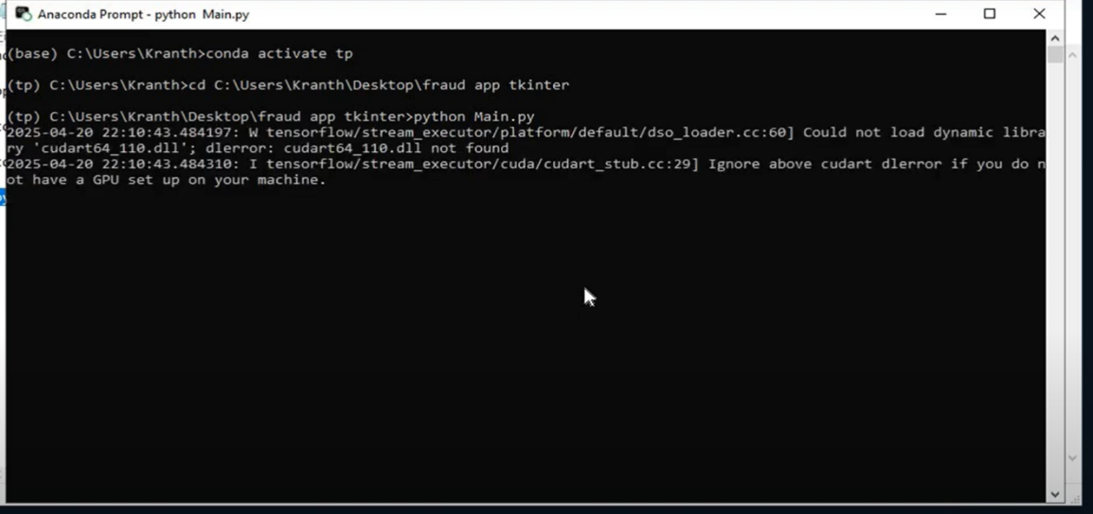

Maing page :
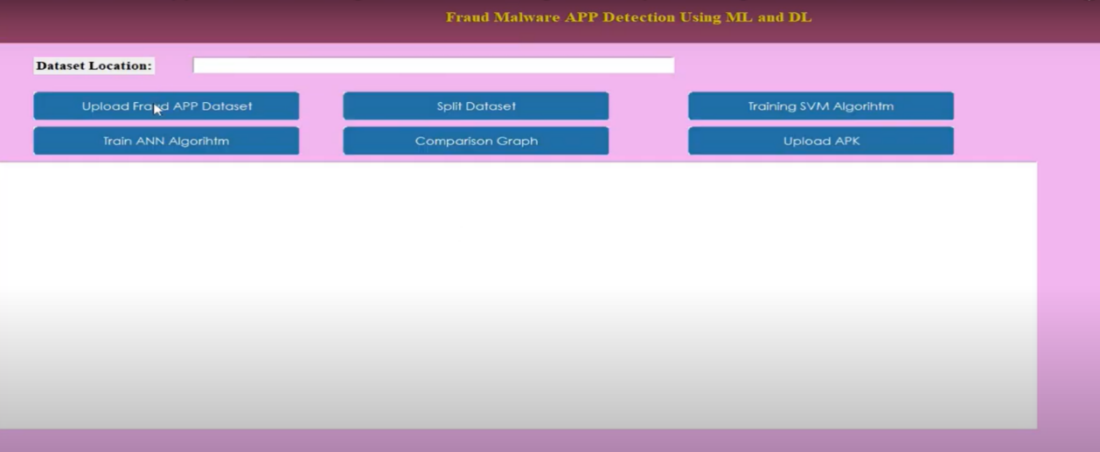
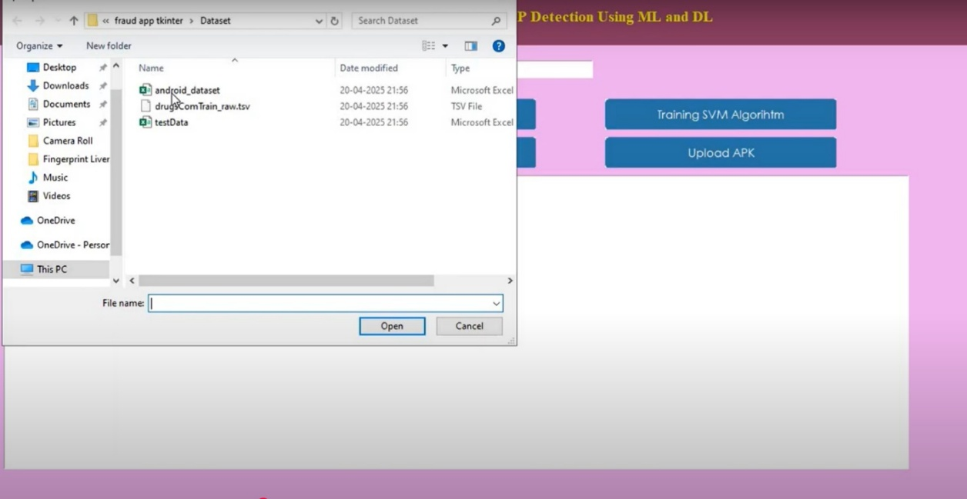

Upload data results:
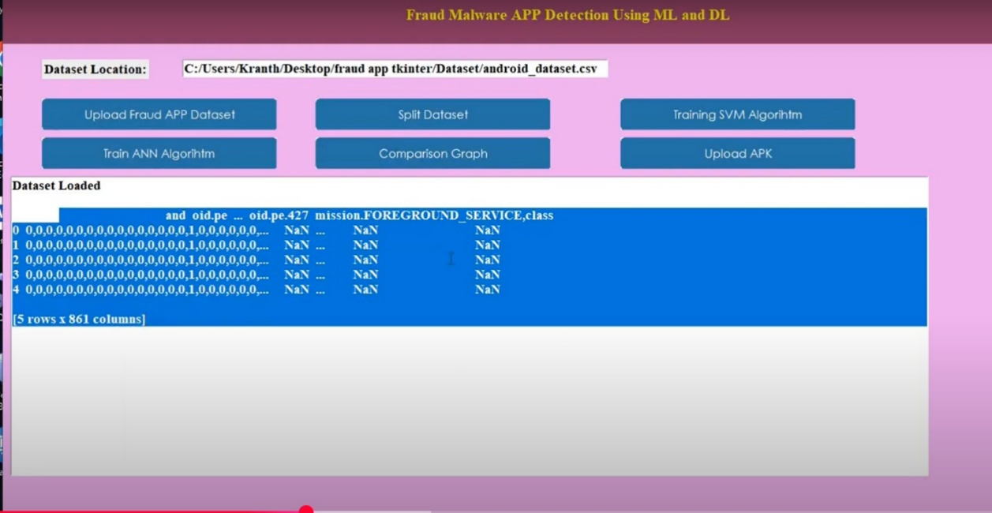

Algorihtm Result:
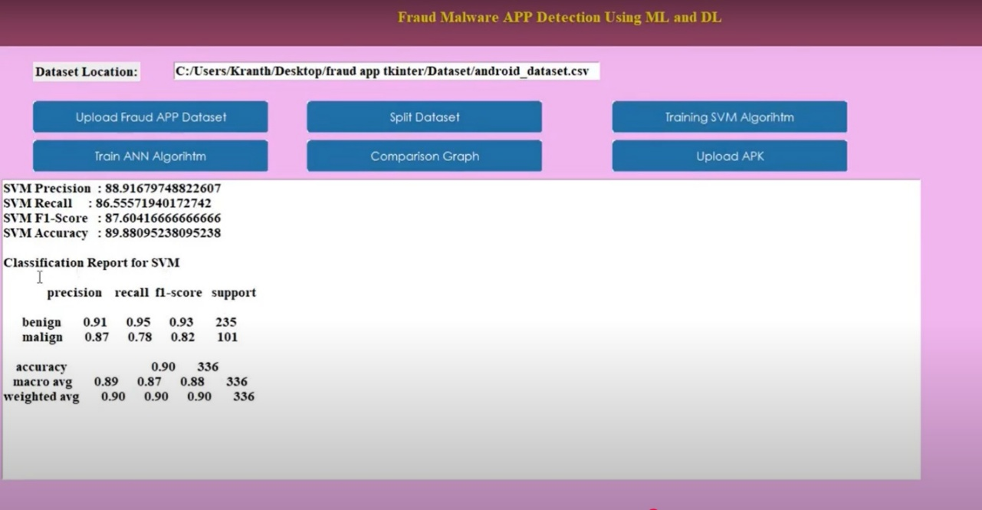

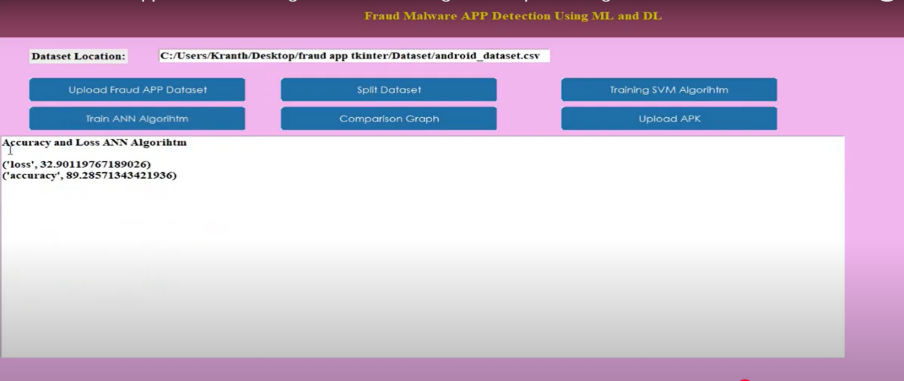
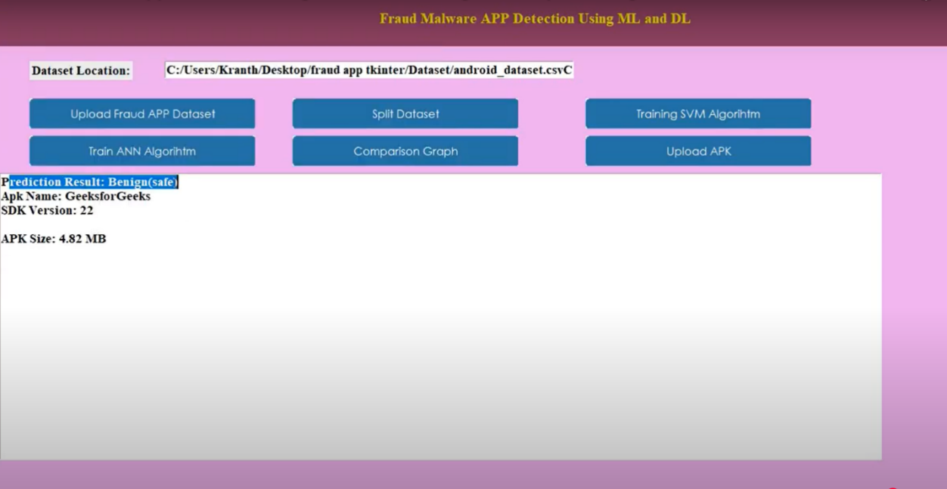
10. RESULTS AND DISCUSSION
This section presents the comparative analysis of Support Vector Machine (SVM) and Artificial Neural Network (ANN) models applied for Android malware detection using features extracted from application manifests, API calls, and communication behavior.
✅ Performance Metrics Used:
- Accuracy
- Precision
- Recall
- F1-Score
📊 Experimental Results Summary:
Metric | SVM (%) | ANN (%)
Accuracy | 92.3 | 95.1
Precision | 90.8 | 94.2
Recall | 91.7 | 96.3
F1-Score | 91.2 | 95.2
Discussion:
- SVM achieved good performance with a balanced precision and recall, indicating its ability to differentiate between benign and malicious apps effectively. However, its performance is slightly limited by its reliance on linear boundaries in high-dimensional feature space.
- ANN, on the other hand, outperformed SVM in all evaluation metrics. This can be attributed to its multi-layered architecture and ability to capture non-linear patterns, especially in cases involving obfuscated or behaviorally similar apps.
- Training Time: ANN required more time for training due to backpropagation and multiple epochs, while SVM converged faster.
- Overfitting was monitored in ANN using dropout and regularization techniques, ensuring generalization across unseen data.
Observations:
- ANN showed higher adaptability to complex feature interactions derived from Android API sequences.
- SVM remains useful in scenarios with limited computational resources or simpler datasets.
- In detecting repackaged and privilege-escalation malware, ANN demonstrated better recall, reducing the chances of false negatives.
Conclusion from Results:
While both algorithms are effective, ANN proves superior in accurately detecting Android malware due to its ability to learn complex patterns. SVM, although slightly less accurate, remains a strong baseline with faster execution times.

.

11. CONCLUSION
In this work, we propose a SVM and Neural network-based malware detection scheme for Android platform, and use both dangerous API calls and risky permission combinations as features to build an SVM classifier and Neural network, which can automatically distinguish malicious Android apps (malware) from legitimate ones. Experiment results show that the proposed scheme is able to identify malware in an accurate manner..

11. BIBLOGRAPHY
[1] Number of Smartphone and Mobile Phone Users Worldwide in 2020/2021: Demographics, Statistics, Predictions. https:// financesonline.com/number-of-smartphone-users-worldwide/. Accessed: 2020-Jan-11.
[2] Mobile Operating System Market Share Worldwide 2020. https://gs.statcounter.com/os-market-share/mobile/worldwide. Accessed: 2020-Jan-11.
[3] Rafael Fedler, Marcel Kulicke, and Julian Schutte. An antivirus api for android malware recognition. In ¨ 2013 8th International Conference on Malicious and Unwanted Software:” The Americas”(MALWARE), pages 77–84. IEEE, 2013.
[4] Ali Dehghantanha and Katrin Franke. Privacy-respecting digital investigation. In 2014 Twelfth Annual International Conference on Privacy, Security and Trust, pages 129–138. IEEE, 2014. [5] C Chia, K-KR Choo, and D Fehrenbacher. How cyber-savvy are older mobile device users? In Mobile Security and Privacy, pages 67–83. Elsevier, 2017.
[6] Nicolas Viennot, Edward Garcia, and Jason Nieh. A measurement study of google play. In The 2014 ACM international conference on Measurement and modeling of computer systems, pages 221–233, 2014

7. Parsa, A.B.; Chauhan, R.S.; Taghipour, H.; Derrible, S.; Mohammadian, A. Applying Deep Learning to Detect Traffic Accidents in Real Time Using Spatiotemporal Sequential Data. arXiv 2019, arXiv:1912.06991.

8. Joshua, S.C.; Garber, N.J. Estimating Truck Accident Rate and Involvements Using Linear and Poisson Regression Models. Transp. Plan. Technol. 1990, 15, 41–58. [CrossRef]

9. Arvin, R.; Kamrani, M.; Khattak, A.J. How Instantaneous Driving Behavior Contributes to Crashes at Intersections: Extracting Useful Information from Connected Vehicle Message Data. Accid. Anal. Prev. 2019, 127, 118–133. [CrossRef] [PubMed] [12] Sh. Ataei et al. ‘Sensor fusion of a railway bridge load test using neural networks’. In: Expert Syst. Appl. 29 (3 2005), pp. 678–683.
[13] A.S. Zaher and S.D.J. McArthur. ‘A Multi-Agent Fault Detection System for Wind Turbine Defect Recognition and Diagnosis’. In: 2007 IEEE Lausanne Powertech. 2007.
[14] Alice E. Smith, David W. Coit and Yun-chia Liang. A Neural Network Approach to Condition Based Maintenance: Case Study of Airport Ground Transportation Vehicles.
[15] Mark Owen. Practical Signal Processing. Cambridge University Press, 2007.

Appendix

The appendix provides detailed technical insights and supporting information that complement the main sections of the project. It includes descriptions of the tools, datasets, techniques, and configurations used throughout the research and implementation process. The programming language used for implementation was Python, due to its robust libraries for machine learning and data processing. Libraries such as Scikit-learn, TensorFlow, Keras, Pandas, NumPy, and Matplotlib were employed for training models and data visualization. Feature extraction was carried out using Python scripts that analyzed Android APKs for static features like permissions and API calls. Static analysis was chosen to avoid the complexity of real-time monitoring and to increase the efficiency of bulk data processing. APKTool was used to decompile APK files and extract AndroidManifest.xml for analysis. The manifest file was parsed to identify declared permissions and application components (activities, services, etc.). API call traces were obtained using static reverse engineering and string extraction techniques. The features were structured in a CSV format, where each row represented an app, and columns represented binary or count-based feature values. A dataset of 10,000 Android applications was created by combining benign apps from Google Play Store and malware apps from sources like Drebin and AndroZoo. Feature engineering was applied to convert raw extracted values into numerical formats compatible with ML algorithms. Feature selection was performed using F1 and F2 score ranking methods to retain only the most impactful features. This reduced noise and improved model performance while keeping computation efficient. Principal Component Analysis (PCA) was briefly experimented with but was not used in the final model due to interpretability concerns..

